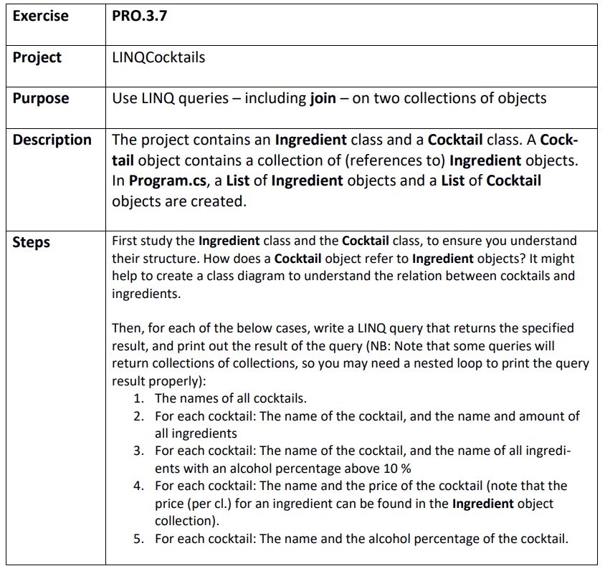

Step 1
C:\Git\OOProg25\Chap\Prog03\MySolution\PRO.3.7 - LINQCocktails\LINQCocktails\LINQCocktails.sln

